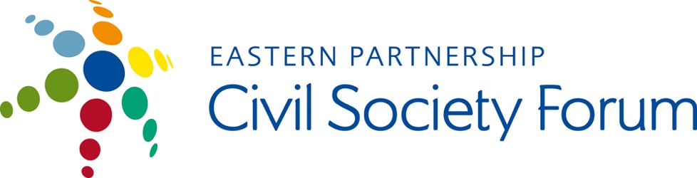

We, members of the Eastern Partnership Civil Society Forum Georgian National Platform (EaP CSF GNP) are concerned by the developments in Public Broadcaster Adjara TV and Radio. The ongoing processes in television undermines not only the Public Broadcaster, but also the democratic development of the country.

It is outrageous that the new management of the channel completely ignores not only the statements made by authoritative organizations, such as Reporters Sans Frontier but also the calls of the Public Defender and the protest of local civil society organizations and their own employees. The people involved in the creation of journalistic product of the Public Broadcaster assessed as impartial and objective by a number of international or local authoritative organizations are gradually dismissed from editorial activities of the channel. It is noteworthy to mention that some employees announced the strike on March 2 and are waiting for the results of the mediation. It is entirely unclear how the processes will be carried out in the Public Broadcaster's Adjara TV and Radio.

The role of the Public Broadcaster and impartial editorial policy have acquired special importance in the election year. Therefore, the current situation raises suspicion that the government attempts to monopolize the media outlets before the elections. We, the members of the Georgian National Platform express solidarity with the employees of the Public Broadcaster's Adjara TV and Radio who oppose such interventions. We urge international organizations to provide effective support to the staff of Public Broadcaster's Adjara TV and Radio.

Undersigned Organizations:
- Georgian Young lawyers Association (GYLA)
- Liberal Academy Tbilisi
- Journalism Resource Center
- Association and Radio "Green Wave"
- International Business and Economic Development Centre
- Association of Business Consulting Organizations of Georgia
- The Greens Movement of Georgia/ Friends of the Earth Georgia
- World Experience for Georgia (WEG)
- Youth Alternative
- Georgian Trade Unions Confederation (GTUC)
- Research-Intellectual Club "Dialogue of Generations"
- Samtskhe-Javakheti Regional Association "Toleranti"
- Human Rights Centre (HRIDC)
- Foundation for Media Development
- International Business Development and Investment Promotion Centre
- International Council on Monuments and Sites (ICOMOS)
- New Generation for Democratic Georgia
- Media Monitoring Center of Georgia
- Youth Association Droni
- Association European Studies for Innovative Development in Georgia
- Association "Woman in Business"
- Save Future Generation
- International Center for Advancement of Research, Technology and Innovation

